**Customer Dashboard**

**There’s a requirement for Customer Dashboard with the following charts into it -**

1. **Transaction Volume by date (bar chart)**

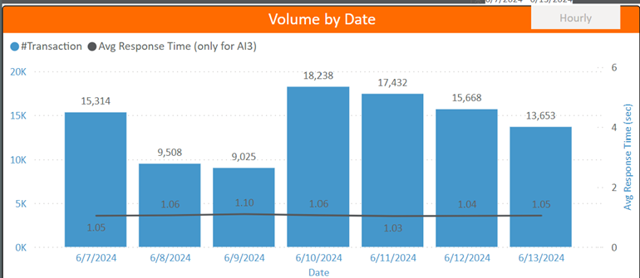

1. **Score distribution (bar chart)**

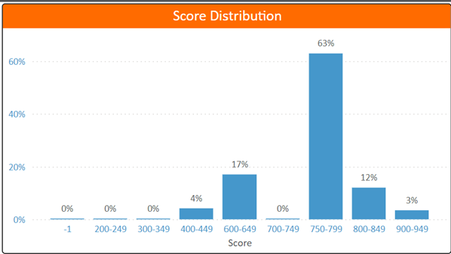

1. **Response time distribution (bar chart)**

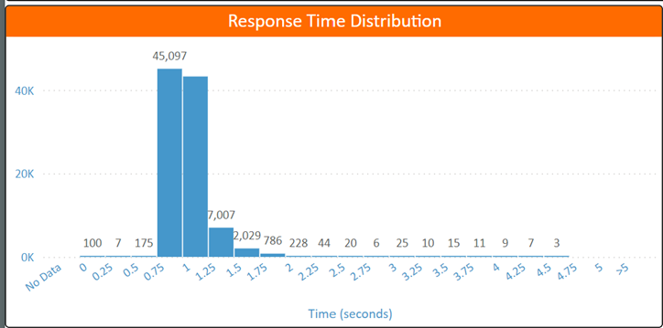

1. **Transaction Status distribution (pie chart)**

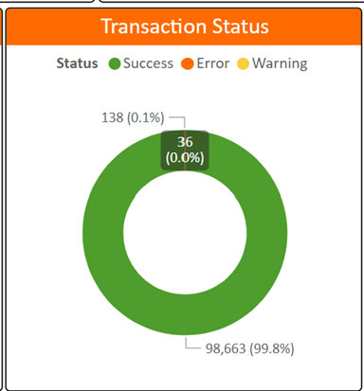

1. **Reason code distribution (bar chart)**

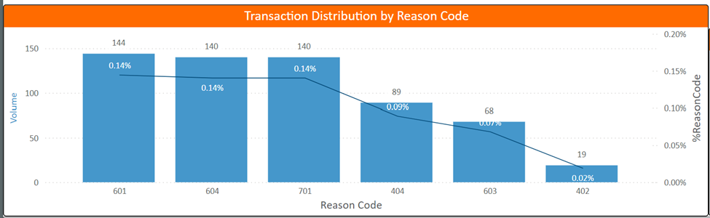

**Underlying Assumptions –**

1. No Customer can sneak peek into other’s Customer Dashboard.
2. No un-authorized access to the Customer Dashboards.
3. Customer has a flexibility to choose the time frame

7 days/15 days/30 days/45 days/60 days. (> 60 days affects performance)

**System Design –**

Customer Login >>> Credentials Authenticate (On Okta Authentication) >>> Redirects to Customer Dashboard WebPage >>> Logout >>> Redirects Login Page again.

Customer Login >>> Credentials Not Authenticate >>> Shows Error >>> Redirects to Login Page Again.

**Tech Stack –**

SQL/Plotly/Dash/Flask/Bootstrap/AJAX/JQuery

**Layouts –**

Prepared two layouts; and it’s upto you which layout you wish for production.

**Code Go through**

If you wish too

**Demo**